Smart Pantry
A Pantry-Aware Meal Recommendation System for Food Waste Reduction
Patrice Jones
Full Sail University
Master of Science in Computer Science
Thesis Draft 2 – Advisor Review
July 2026

Abstract
Household food waste is often connected to poor pantry visibility, forgotten ingredients, repeated purchases, and difficulty deciding what to cook with food already available. Existing applications support recipe discovery, meal planning, shopping lists, or inventory management, but these functions are often separated. This thesis presents Smart Pantry, a web-based pantry management and meal recommendation platform designed to connect household inventory with practical, explainable meal suggestions.
Smart Pantry is part of a broader Pantry & Meal Planning Study platform that includes a neutral Wix study website, structured participant instructions, pre-study and post-study surveys, three comparison activities, activity feedback forms, application logging, and an administrative dashboard. Participants compare a manual Pantry Notes Tracker, the free version of Samsung Food as an Ingredient Recipe Finder, and the Smart Pantry Recommendation Tool. This within-subject comparison is intended to evaluate pantry organization, meal-planning support, recommendation usefulness, ingredient utilization, and overall usability.
The current system uses a React frontend, FastAPI backend, Supabase/PostgreSQL database, Vercel and Render deployment, a cleaned recipe dataset, UPC and food-data services, transparent recommendation scoring, and a Random Forest support model for Nutrition Fit. Recommendation cards display Pantry Match, Coverage, Nutrition Fit, Smart Score, expiration priority, missing ingredients, recommendation evidence, and Smart Swap options. Participant actions are stored in Recommendation History and summarized through the admin dashboard.
The study uses mixed methods. Matching pre-study and post-study items will be analyzed with descriptive statistics and a paired-samples t-test when assumptions are met, with the Wilcoxon signed-rank test used as a non-parametric alternative. Activity ratings, application logs, and open-ended responses provide additional evidence. The expected contribution is both a practical pantry-first recommendation platform and a repeatable framework for comparing manual tracking, an existing consumer tool, and a custom recommendation system within one participant study.
Keywords: food waste, pantry management, meal recommendation, recommendation systems, Smart Pantry, Nutrition Fit, Smart Swaps, human-computer interaction, machine learning

Table of Contents
Right-click and update the Table of Contents in Microsoft Word.

List of Figures
Figure 3.1. Participant study workflow.
Figure 4.1. Smart Pantry research platform architecture.
Figure 4.2. Pantry & Meal Planning Study website.
Figure 4.3. Smart Pantry participant login.
Figure 4.4. Participant dashboard.
Figure 4.5. Pantry management interface.
Figure 4.6. Pantry Notes Tracker.
Figure 4.7. Smart Pantry recommendation card and evidence.
Figure 4.8. Recommendation History.
Figure 4.9. Administrator outcome and Activity 1 summary.
Figure 4.10. Administrator evidence and export interface.
Figure 4.11. High-level database relationships.
Figure 4.12. Smart Pantry recommendation workflow.

List of Tables
Table 2.1. Comparison of pantry management approaches.
Table 3.1. Study activities and comparison conditions.
Table 3.2. Study data sources.
Table 3.3. Verification and validation criteria.
Table 5.1. Primary evaluation metrics.

Chapter 1 – Introduction

1.1 Introduction
Food waste remains a serious household, economic, and environmental concern. In the United States, an estimated 30 to 40 percent of the food supply is not consumed [1]. At the household level, waste can occur when ingredients are forgotten, purchased more than once, stored without clear expiration awareness, or left unused because the household does not know what meal can realistically be prepared from the available food. These problems are not always caused by a lack of recipes. In many cases, the larger issue is a lack of connection between pantry inventory and everyday meal decisions.
Recipe websites, shopping-list tools, and meal-planning applications have made food-related information easier to access. However, these tools often begin with a recipe, shopping trip, or weekly plan rather than the food already present in the home. Effective pantry support requires more than storing a list. A useful system should help the user understand what is available, what should be used first, what can be prepared now, and what small changes would make a meal possible.
This research presents Smart Pantry, a web-based pantry management and meal recommendation platform created to support those decisions. The Smart Pantry application combines pantry inventory, expiration awareness, profile preferences, transparent recommendation evidence, Smart Swaps, Nutrition Fit, recommendation history, and administrative reporting. The application is also connected to a neutral Pantry & Meal Planning Study website that guides participants through informed consent, surveys, and three comparison activities.
The evaluation compares a manual Pantry Notes Tracker, Samsung Food as an Ingredient Recipe Finder, and the Smart Pantry Recommendation Tool. Using the same participants across the three activities provides a consistent way to examine how manual tracking, an established consumer tool, and a pantry-first recommendation platform support household food decisions.

1.2 Problem Statement
Despite the growing number of recipe and meal-planning applications, households continue to struggle with knowing what food is available, remembering which items should be used soon, and identifying realistic meals that use current inventory. Existing tools commonly provide strong recipe collections, grocery lists, or inventory features, but those functions are frequently separated. A participant may still need to move between a pantry list, recipe search, and shopping list before making a decision.
This separation can lead to repeated purchases, unused ingredients, and low confidence when planning meals. Recommendation systems may also provide limited explanation for why a recipe appears, whether the user has enough ingredients, or how an unavailable ingredient can be replaced. From a research perspective, commercial systems generally do not provide the participant workflow, application logs, research metrics, and export tools needed to evaluate behavior within a controlled study.
The problem addressed by this thesis is therefore both practical and technical: households need clearer support for connecting pantry contents to meal decisions, and researchers need a structured way to evaluate whether pantry-aware recommendations improve the participant experience and intentional ingredient use.

1.3 Purpose of the Study
The purpose of this research is to design, develop, and evaluate a pantry-aware meal recommendation system that helps users organize household food and make more informed decisions with ingredients already available. The study examines whether combining inventory management, expiration awareness, recommendation explanations, substitutions, and participant interaction records provides value beyond manual tracking and an existing recipe-finder application.
The study also introduces a complete research workflow. Participants move through a neutral study website, complete a baseline survey, use three comparison activities, submit feedback after each activity, and complete a final survey. Smart Pantry application records are then combined with survey responses using a consistent participant identifier.

1.4 Research Question and Supporting Questions
The primary research question is:
Does Smart Pantry improve pantry awareness, recommendation usefulness, and ingredient utilization compared with manual pantry tracking and an existing ingredient-based recipe application?
The supporting questions are:
- Does Smart Pantry help participants understand what pantry items they have available?
- Do participants perceive Smart Pantry recommendations as useful, realistic, and connected to their available ingredients?
- Does the system improve participant confidence when deciding what to cook?
- How does the usability of Smart Pantry compare with the Pantry Notes Tracker and Samsung Food?
- Which method do participants prefer after completing all three activities?

1.5 Hypothesis
Participants will report stronger pantry awareness, recommendation usefulness, and ingredient utilization after completing the Smart Pantry activity than they report for their baseline pantry-management approach. Smart Pantry is also expected to receive higher ratings for expiration support and recommendation explanation, while Samsung Food may receive stronger ratings for recipe variety and commercial polish.

1.6 Research Objectives
- Design and deploy a full-stack pantry management and recommendation platform.
- Compare manual tracking, Samsung Food, and Smart Pantry through one structured participant study.
- Evaluate pantry awareness, meal-planning confidence, recommendation quality, ease of use, and participant preference.
- Measure recommendation actions and ingredient-use evidence through application logs and Recommendation History.
- Provide clear recommendation evidence through Pantry Match, Coverage, Nutrition Fit, Smart Score, expiration priority, and Smart Swaps.
- Develop an administrator interface that supports participant monitoring and CSV data export.

1.7 Scope of the Study
The study focuses on adult participants who purchase groceries, prepare meals, or help manage food within their household. The comparison is limited to the Pantry Notes Tracker, the free version of Samsung Food, and Smart Pantry. The study does not attempt to compare every pantry application or evaluate paid Samsung Food features.
Smart Pantry includes manual pantry entry, UPC lookup, receipt-assisted or OCR-supported entry, CSV import support, profile preferences, recommendation generation, Smart Swaps, Recommendation History, and administrative study evidence. External services are used as supporting data sources; the study does not independently validate every barcode or OCR result produced by a third-party provider.

1.8 Significance of the Study
This research is significant because it studies a pantry-first approach rather than treating recipe discovery as the complete solution. Smart Pantry is designed to help participants move from inventory awareness to a practical meal decision while showing the evidence behind each recommendation.
The project contributes in three areas. First, it demonstrates a full-stack software engineering solution using modern web technologies and cloud deployment. Second, it develops an explainable pantry-aware recommendation workflow that combines rule-based scoring with a machine learning support layer. Third, it provides a structured research platform that joins surveys, comparison activities, application evidence, and administrative reporting.

1.9 Organization of the Thesis
Chapter 2 reviews household food waste, pantry-management approaches, related recommendation research, commercial applications, and the research gap. Chapter 3 presents the study design, recruitment, procedures, data collection, statistical analysis, verification and validation, and ethical considerations. Chapter 4 explains the system architecture, recommendation engine, database design, and participant and administrator interfaces. Chapter 5 presents the evaluation framework, pilot observations, limitations, and expected contributions. Chapter 6 discusses the overall project, future work, and conclusion.

Chapter 2 – Literature Review and Related Work

2.1 Household Food Waste and Pantry Awareness
Food waste affects household budgets, resource use, and environmental sustainability. USDA estimates place U.S. food waste between 30 and 40 percent of the food supply [1]. The EPA also emphasizes prevention and source reduction before disposal, reinforcing the value of helping households use food before it becomes waste [2].
At home, waste can begin with poor visibility. Ingredients may be distributed across a pantry, refrigerator, and freezer, and a household may not remember what was purchased or when it should be used. Inventory awareness alone is not always enough. A person may know that an item exists but still lack a practical plan for using it. This supports systems that connect pantry information with meal-planning assistance.

2.2 Pantry Management and Meal-Planning Approaches
Manual pantry management includes memory, paper lists, notes applications, and spreadsheets. These methods are inexpensive and familiar, but their accuracy depends on regular updates. As the number of items increases, the list can become incomplete or difficult to maintain. Manual methods also provide no automated connection between the inventory and possible meals.
Digital tools improve access and organization. Grocery-list applications, meal planners, and recipe websites can store information across devices and provide faster search. Ingredient-first recipe systems further reduce search effort by using available foods as the starting point. However, the benefits depend on whether the system supports accurate inventory, realistic ingredient coverage, expiration priority, and clear explanation.

2.3 Existing Applications

2.3.1 Samsung Food
Samsung Food is a consumer cooking platform that supports recipe organization, meal planning, shopping lists, ingredient search, and access across web and mobile devices [3]. Its polished interface, recipe ecosystem, and planning tools make it a strong comparison for participant experience. Samsung Food also includes a Food List feature for managing food across storage locations, although some advanced pantry-to-recipe and “use it up” capabilities are associated with its subscription features [4].
For this study, the free version is used as an Ingredient Recipe Finder. Participants evaluate how well the application helps them find recipe ideas from selected ingredients. Smart Pantry is not expected to match Samsung Food's commercial scale or recipe community; the comparison instead examines whether Smart Pantry's stronger pantry focus, expiration evidence, and research logging provide additional value.

2.3.2 SuperCook
SuperCook uses an ingredient-first approach. Users identify ingredients they have, and the service returns recipes that can be prepared from those selections [5]. This model demonstrates the value of beginning with available food rather than a recipe title. Its primary focus is recipe discovery, while Smart Pantry adds persistent inventory, quantities, expiration data, profile rules, recommendation evidence, and study metrics.

2.4 Related Recommendation Research
Ortiz et al. connected food inventory management with recipe recommendation for perishable items, supporting the idea that inventory should influence meal suggestions [6]. RecipeIS explored recipe recommendation from recognized ingredients [7], while Chhipa et al. used TF-IDF for recipe recommendation based on ingredient similarity [8]. These studies show that ingredient matching is a reasonable recommendation foundation, but a household decision may also depend on quantities, expiration, allergies, substitutions, and explanation.
Explainable recommendation research argues that users benefit from understanding the reason behind a recommendation [9], [10]. Smart Pantry applies this principle through visible Pantry Match, Coverage, Nutrition Fit, matched ingredients, missing ingredients, expiration evidence, and Smart Score components.

2.5 Current Limitations
The reviewed systems and studies each address useful parts of the problem, but several limitations remain. Commercial tools may emphasize recipe discovery, weekly planning, or shopping more than persistent pantry evidence. Manual methods provide control but no decision support. Academic models often focus on algorithm performance without providing a complete participant workflow, administrative dashboard, and study-data exports.
Recommendation transparency is another limitation. A recipe can appear relevant while still requiring unavailable ingredients, unrealistic quantities, or substitutions that do not preserve the ingredient's role. Smart Pantry addresses this by separating exact pantry match from coverage with swaps, displaying missing ingredients, and allowing participants to add their own custom substitution.

2.6 Research Gap and Smart Pantry Contribution
The research gap is the limited integration of pantry inventory, expiration priority, recommendation explanation, substitutions, participant interaction evidence, and structured study administration within one platform. Smart Pantry addresses this gap through a web-based research platform that connects a neutral study website, three comparison activities, a full-stack pantry application, recommendation logging, and administrative exports.
The contribution is not a claim that Smart Pantry replaces every commercial cooking application. Instead, the project evaluates whether a focused, transparent pantry-first system can improve the participant's understanding of available food and support more intentional meal decisions.
Table 2.1. Comparison of Pantry Management Approaches
Feature | Manual Pantry Tracker | Samsung Food (Free) | Smart Pantry
Persistent inventory | Manual | Available | Available
Quantity and unit tracking | Manual | Limited / interface-dependent | Available
Expiration-date emphasis | Manual | Limited in free comparison workflow | Available with alerts
Ingredient-based recipe discovery | No | Available | Available
Pantry Match and Coverage evidence | No | Limited | Available
Machine learning-based Nutrition Fit | No | Not part of this study condition | Available
Suggested and custom Smart Swaps | No | Not part of this study condition | Available
Recommendation explanation | No | General recipe information | Detailed evidence panel
Recommendation History | No | Consumer history features | Study action history
UPC / receipt / CSV entry support | No | Varies by feature | Supported in Smart Pantry workflow
Participant research workflow | No | No | Available
Admin research dashboard and CSV export | No | No | Available

Chapter 3 – Methodology

3.1 Research Design
This study uses a within-subject mixed-methods design. Every participant completes the same three activities in the same order, allowing each person to compare a manual method, an existing consumer application, and Smart Pantry. Quantitative data comes from surveys, activity ratings, and application records. Open-ended responses provide context about what felt useful, confusing, or difficult.

3.2 Participants and Recruitment
Participants must be at least 18 years old and regularly purchase groceries, prepare meals, or help manage food within their household. Recruitment will be conducted through public online outreach, university-related channels, community groups, and social media. Participation is voluntary, and all participants will review the informed consent form before beginning the study. No participant is required to purchase a subscription or pay to use any of the study tools.
The full study is designed for a minimum of 30 participants. Before the full study launch, a pilot test was completed with a small group of participants. The pilot confirmed that the study website, surveys, activity links, login process, pantry tracking, recommendations, and data-collection flow were functioning. It also led to clearer instructions, mobile resizing improvements, loading messages, account support, and changes to the Smart Swap experience.
Each participant uses a unique study username or participant ID. The identifier links survey responses, activity feedback, pantry records, recommendation history, and application evidence while reducing the need to collect unnecessary personal information.

3.3 Study Procedure
Participants complete the study through the Pantry & Meal Planning Study website. The site provides the protocol, survey links, activity instructions, and completion steps. Participants are asked to use the same general pantry items across the three activities when possible so the comparison is fair.
- Review the study protocol and informed consent.
- Complete the pre-study survey.
- Complete Activity 1, the Pantry Notes Tracker, followed by its feedback form.
- Complete Activity 2, Samsung Food as the Ingredient Recipe Finder, followed by its feedback form.
- Complete Activity 3, the Smart Pantry Recommendation Tool, followed by its feedback form.
- Complete the post-study survey and study-completion step.
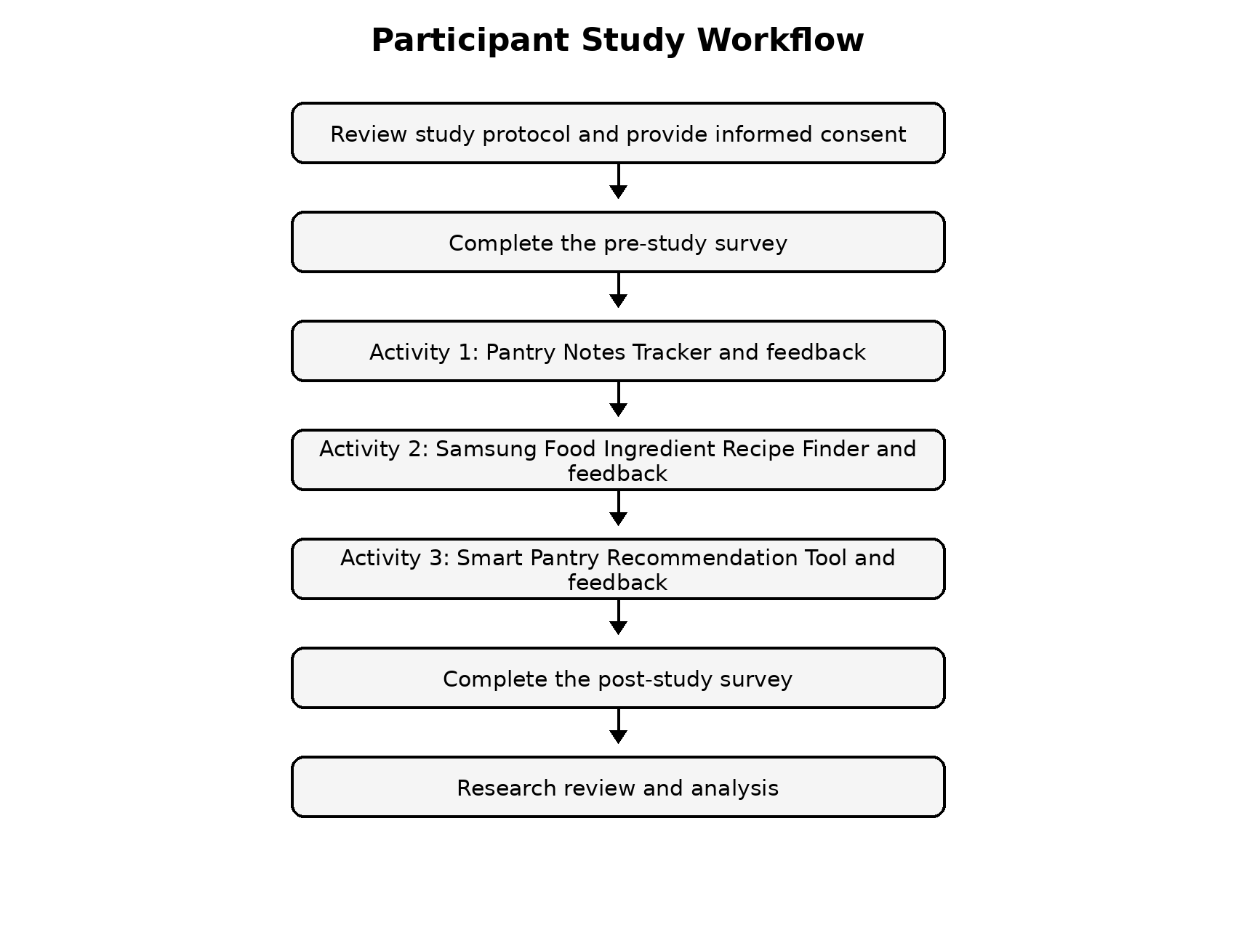
Figure 3.1. Participant study workflow.

3.4 Study Activities
Activity 1 represents a manual baseline. Participants enter pantry, refrigerator, and freezer items into a spreadsheet-style web tracker that does not provide recommendations. Activity 2 represents an established consumer recipe-discovery experience through Samsung Food. Activity 3 represents the proposed pantry-first system, where participants review inventory, expiration information, recommendations, evidence, and Smart Swaps.
Table 3.1. Study Activities and Comparison Conditions
Activity | Method | Primary purpose | Automated recommendation
1 | Pantry Notes Tracker | Manual inventory baseline | No
2 | Samsung Food | Existing recipe-finder comparison | Yes, through the external application
3 | Smart Pantry | Pantry-aware recommendation and evidence | Yes

3.5 Data Collection
The study combines Google Forms responses with application records. The pre-study survey establishes the participant's starting point. Each activity feedback form measures ease of use, usefulness, meal-planning support, confusion, and missing features. The post-study survey asks participants to compare the three methods.
Smart Pantry records pantry items, quantities, expiration dates, recommendations, recommendation actions, ingredient use, selected or custom swaps, and participant notes. Survey data and application exports are connected using the participant ID.
Table 3.2. Study Data Sources
Data source | Information collected | Purpose
Pre-study survey | Current habits and confidence | Establish baseline
Activity 1 tracker and feedback | Manual inventory and participant experience | Evaluate baseline method
Activity 2 feedback | Recipe-finder experience | Evaluate commercial comparison
Activity 3 feedback | Recommendation and pantry-tool experience | Evaluate Smart Pantry
Smart Pantry logs | Pantry, recommendation, swap, and action records | Provide system evidence
Admin dashboard exports | Combined participant and activity records | Support analysis
Post-study survey | Final comparisons and comments | Measure change and preference

3.6 Statistical Analysis
Descriptive statistics will be calculated first, including response counts, means, medians, standard deviations, frequencies, and percentages. Matching pre-study and post-study items will be evaluated with a paired-samples t-test because the same participants complete both forms. The significance level will be set at α = 0.05.
The distribution of difference scores will be reviewed before using the t-test. If the normality assumption is not reasonably met, the Wilcoxon signed-rank test will be used as a non-parametric alternative. Ratings across the three activities will be compared descriptively. If the final response structure and sample size support a formal repeated-measures comparison, repeated-measures ANOVA or the Friedman test may be considered.
Open-ended responses will be reviewed through thematic coding. Common themes may include ease of use, recipe variety, pantry awareness, expiration support, recommendation clarity, mobile usability, and suggested improvements.

3.7 Verification and Validation
Verification confirms that each technical feature performs as designed. Validation examines whether participants understand the feature and find it useful during the study. The pilot test supported both goals by identifying technical errors and participant-facing confusion before the full launch.
Table 3.3. Verification and Validation Criteria
Feature | Verification criterion | Validation criterion
Login and account separation | Valid users authenticate; accounts retain separate records | Participants log in and cannot view another participant's data
Pantry Notes Tracker | Rows save and reload under the correct account | Participants complete the manual activity without recommendations
Pantry management | Items, units, quantities, and dates save correctly | Participants can review and correct inventory
UPC / receipt / CSV entry | Supported inputs produce reviewable pantry records | Participants can reduce repeated manual entry
Recommendations | Cards load from pantry and profile data | Participants judge suggestions as relevant and understandable
Pantry Match / Coverage | Calculated values reflect required ingredients | Participants understand what can be made and what is missing
Nutrition Fit | Model output is generated and displayed | Participants understand the participant-facing label
Smart Swaps | Suggested and custom swaps save correctly | Participants find substitutions practical or can reject them
Recommendation History | Actions remain attached to the participant | Participants can review prior decisions
Admin dashboard | Metrics and exports populate | Study evidence can be reviewed without direct database queries
Wix and Google Forms links | Buttons open the intended activity or form | Participants follow the sequence without repeated assistance

3.8 Ethical Considerations
Participation is voluntary. Participants review informed consent before beginning and may stop at any time without penalty. A study ID is used to connect records, and participants are instructed not to enter sensitive financial, government-identification, password, or unrelated personal information.
Survey responses are collected through Google Forms, while Smart Pantry stores pantry and application activity in Supabase. Private Samsung Food account data is not collected. Findings will be reported in aggregate, and study exports will be stored in controlled project accounts for academic use.

Chapter 4 – System Architecture and Technical Implementation

4.1 System Overview
Smart Pantry operates as part of a research platform rather than as a standalone recipe application. The Wix study website manages participant instructions and links. Google Forms collects the official surveys and activity feedback. The Pantry Notes Tracker provides a manual baseline, Samsung Food provides an outside comparison, and Smart Pantry provides the proposed pantry-aware recommendation experience.
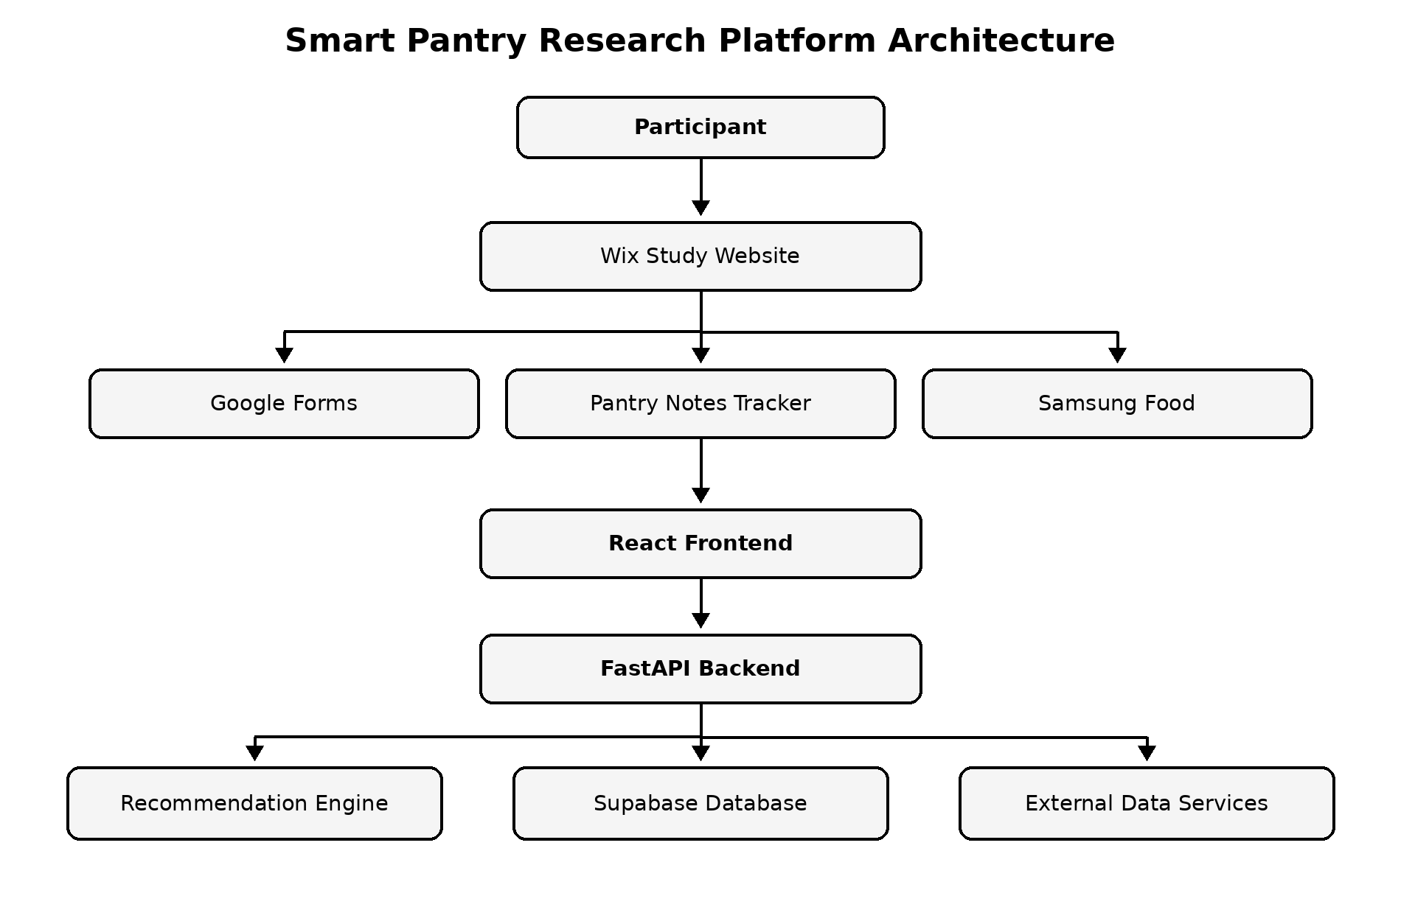
Figure 4.1. Smart Pantry research platform architecture.

4.2 Technical Architecture
The Smart Pantry application uses a React single-page frontend, a FastAPI backend, and a Supabase/PostgreSQL database. The frontend is deployed through Vercel, while the API is hosted through Render. This separation allows interface updates and recommendation-logic updates to be developed independently.
The backend retrieves participant pantry and profile data, communicates with data services, generates recommendations, records actions, and supplies administrative summaries. Supabase stores participant accounts, pantry records, recommendation logs, ingredient-use evidence, and related study data.

4.3 Recommendation Engine
The recommendation engine begins with the participant's saved pantry and profile. Ingredient names are normalized, allergies and avoided foods are filtered, and candidate recipes are compared with the pantry. Each recipe receives evidence for Pantry Match, Coverage, expiration priority, profile fit, Nutrition Fit, missing-ingredient penalties, and simplicity. Duplicate-recipe penalties are used to reduce repetitive recipe families.
Nutrition Fit is the Random Forest machine learning component. It contributes to recommendation ranking but does not replace the explainable pantry factors. This design keeps the participant-facing result understandable while still integrating machine learning into the recommendation process.
Smart Swaps are presented as suggestions rather than guaranteed equivalents. The system can show an approved substitution when one is available, and participants can add their own custom swap. This provides useful flexibility while capturing evidence about how real users modify recipes.
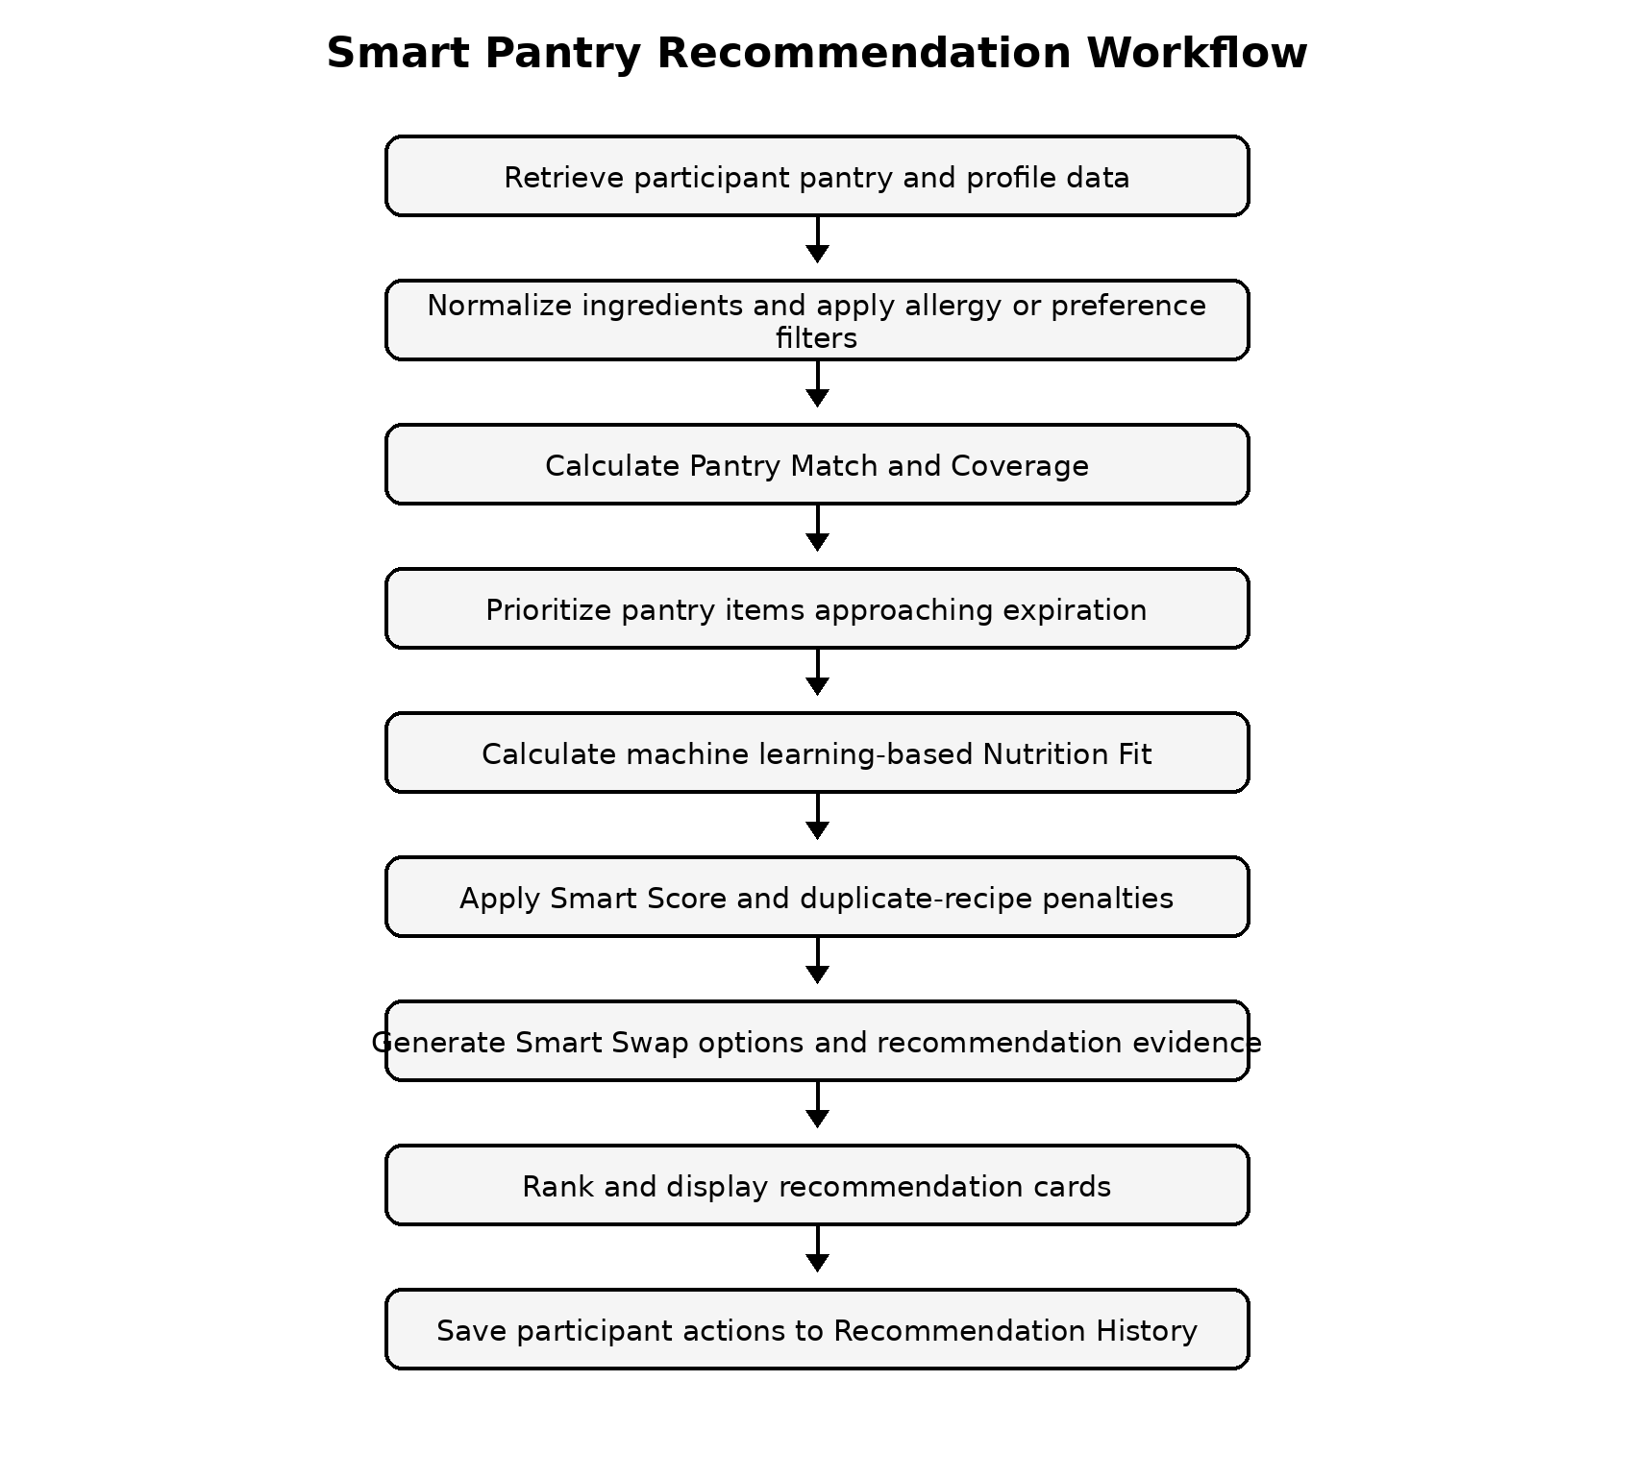
Figure 4.12. Smart Pantry recommendation workflow.

4.4 Database Design
The database is organized around participant accounts and related records. Each participant ID connects profile preferences, pantry items, recommendation logs, ingredient-use evidence, and administrative metrics. Separating these records reduces duplication and supports participant-specific access.
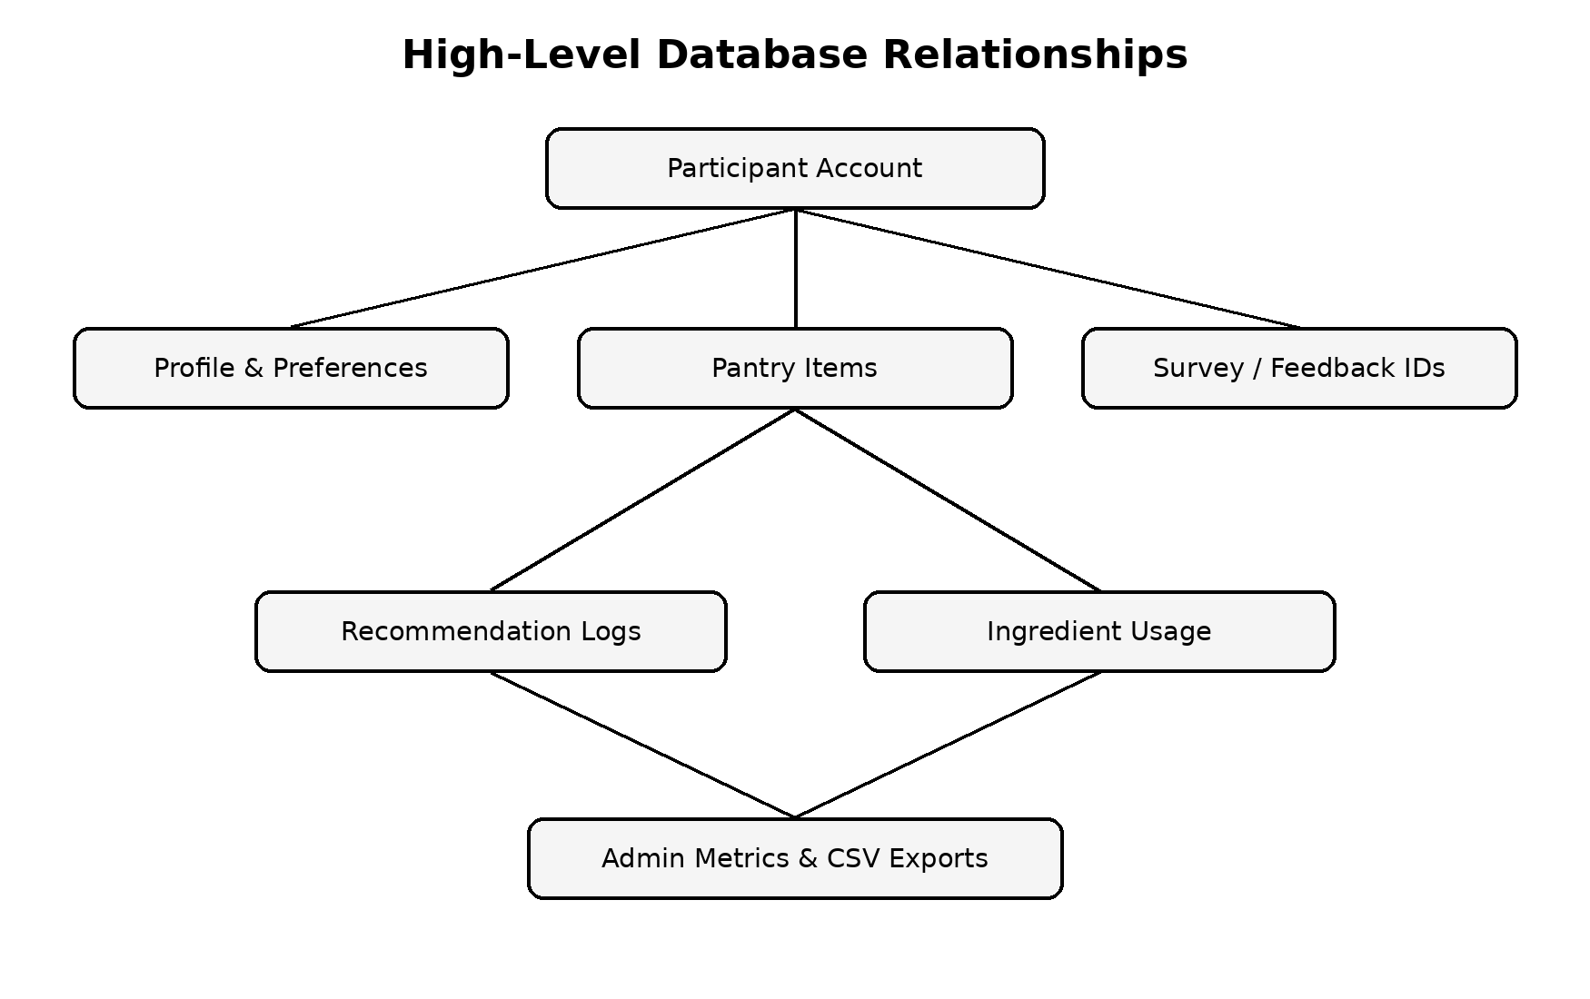
Figure 4.11. High-level database relationships.

4.5 Participant and Research Interfaces

4.5.1 Study Website
The neutral Wix website introduces the study and keeps the official study flow outside the Smart Pantry interface. This helps participants understand the comparison before using the proposed application.
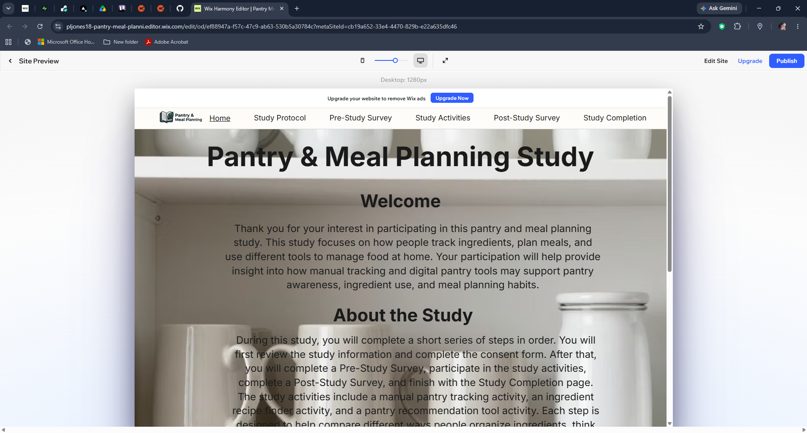
Figure 4.2. Pantry & Meal Planning Study website.

4.5.2 Participant Login
The login page supports participant authentication, account creation, and account-support instructions. Participant accounts keep pantry and recommendation evidence separated.
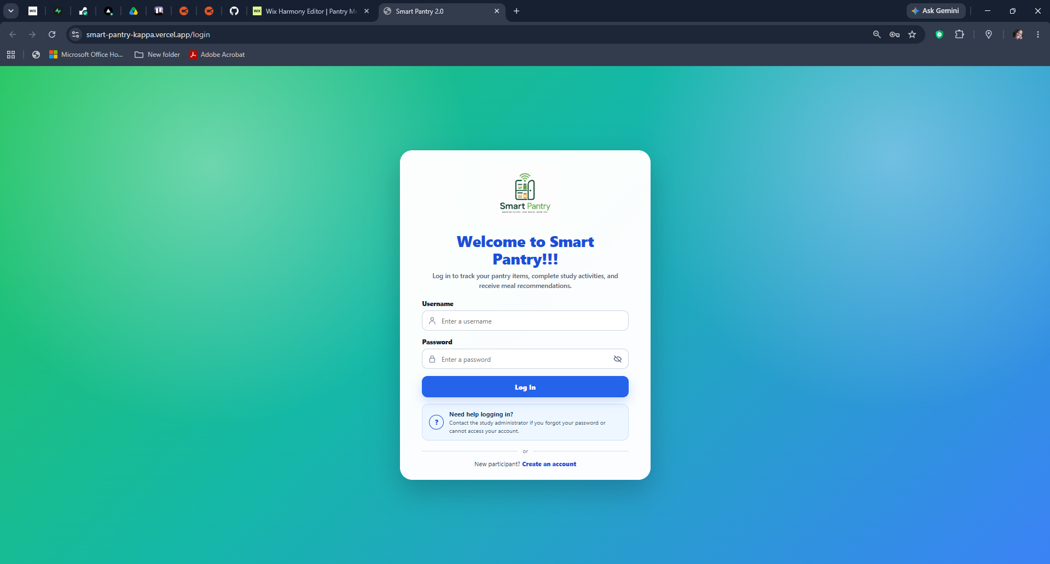
Figure 4.3. Smart Pantry participant login.

4.5.3 Participant Dashboard
The dashboard summarizes pantry totals, combined quantity, items requiring attention, category distribution, suggested grocery items, and a recommended next step. This design reduces the need to search through several pages before understanding current pantry status.
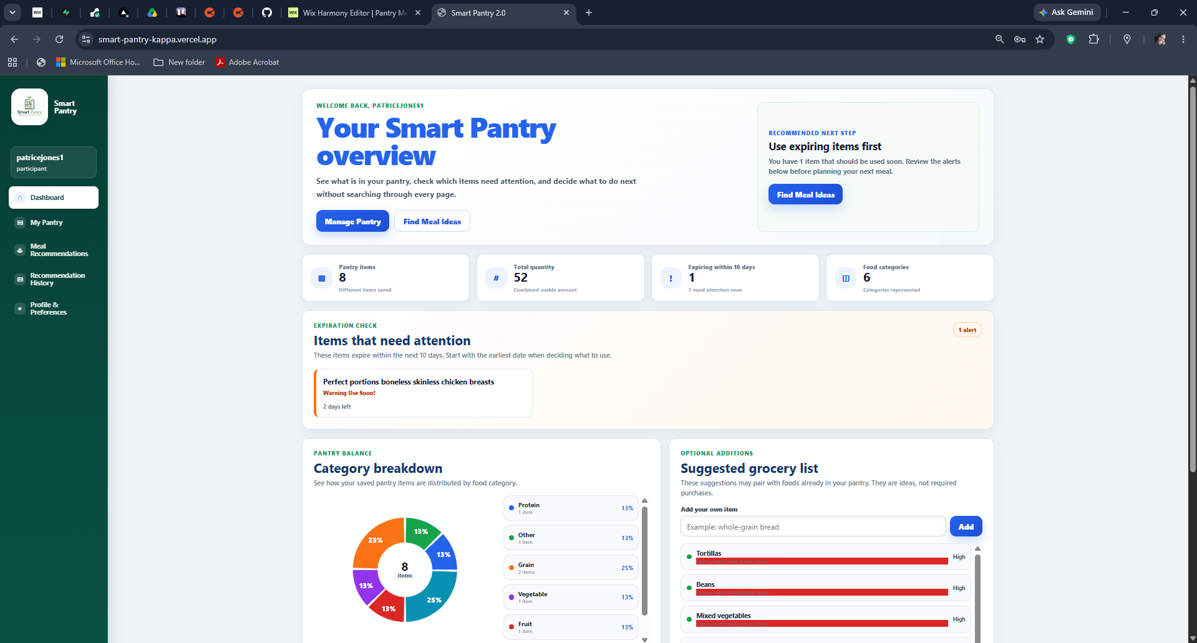
Figure 4.4. Smart Pantry participant dashboard.

4.5.4 Pantry Management
The pantry interface supports item name, category, quantity, unit, container type, expiration date, brand, barcode, and notes. UPC lookup and receipt-assisted entry are presented as faster alternatives while allowing the participant to review information before saving.
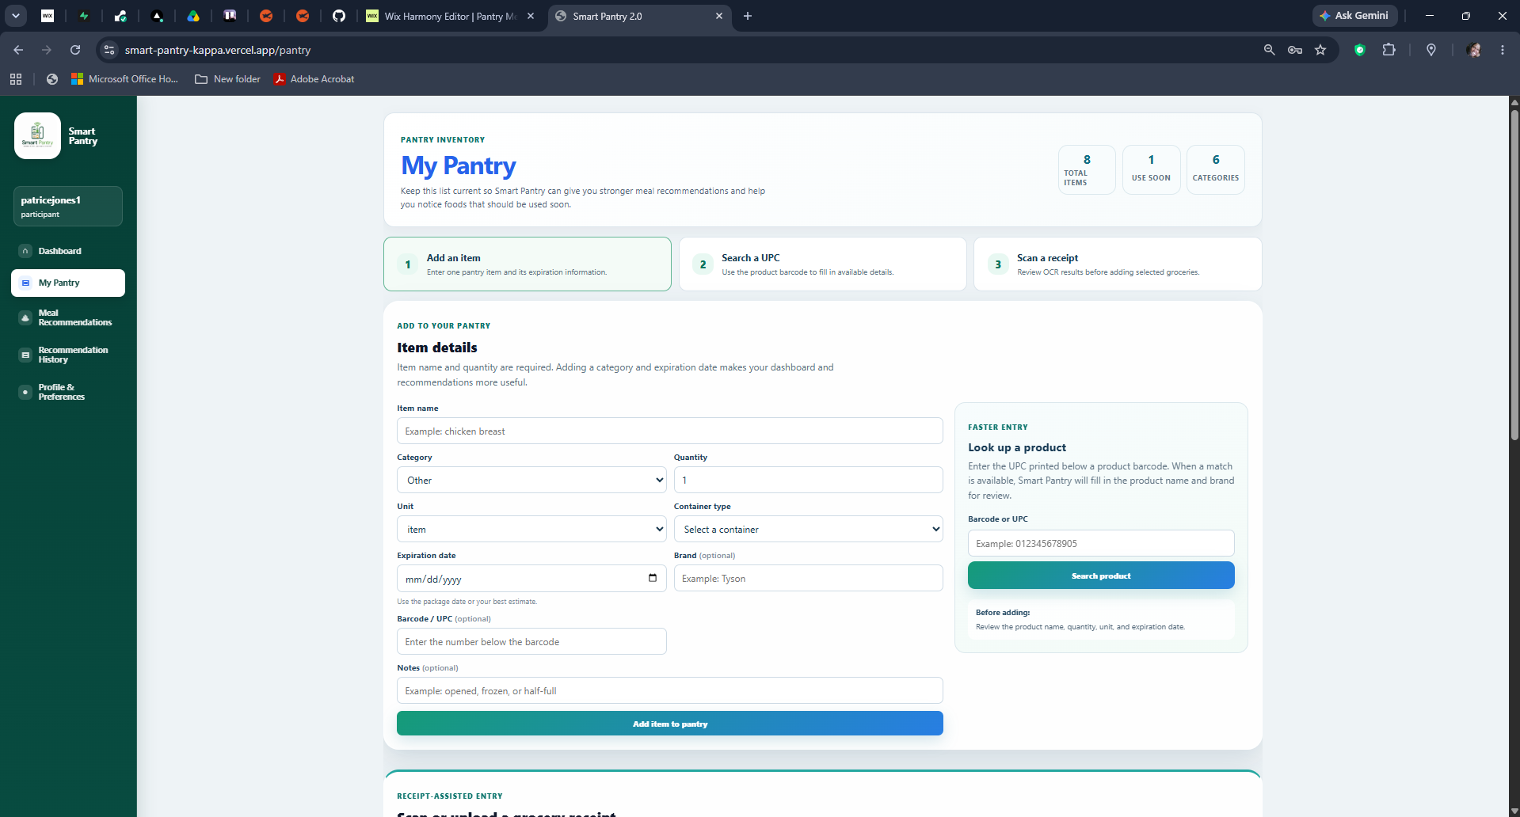
Figure 4.5. Smart Pantry pantry management interface.

4.5.5 Pantry Notes Tracker
The Pantry Notes Tracker is intentionally simple. It provides a spreadsheet-style interface without recommendation scores, recipes, or swaps. Records save under the participant's Activity 1 account and can be reviewed through the admin dashboard.
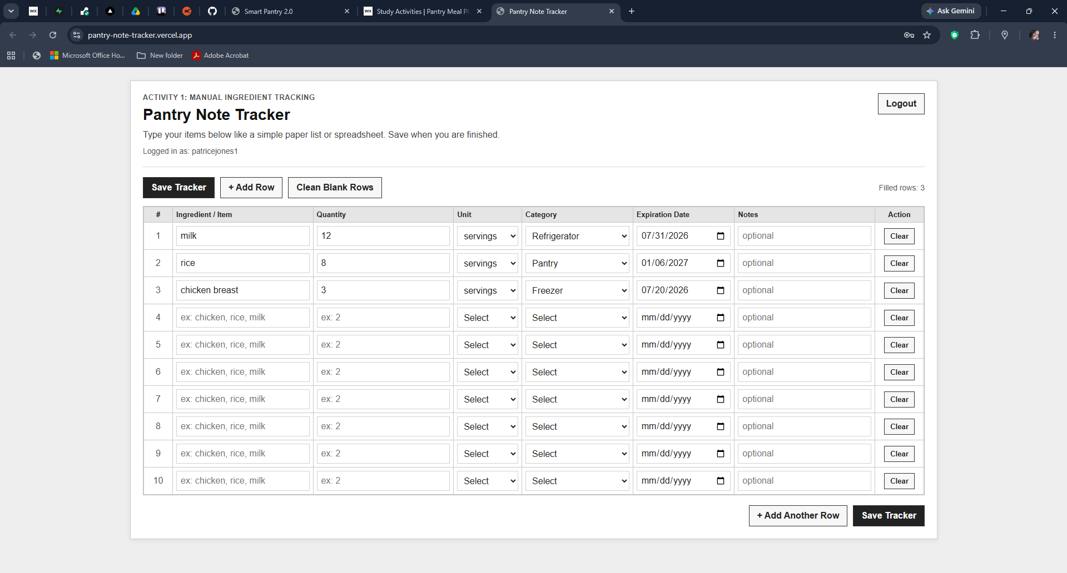
Figure 4.6. Activity 1 Pantry Notes Tracker.

4.5.6 Recommendation Interface
The recommendation interface displays both a quick summary and expanded evidence. The expanded card shows exact Pantry Match, Coverage with swaps, Nutrition Fit, Smart Score, expiring ingredients, matched pantry items, missing ingredients, score components, Smart Swaps, amount used, and participant feedback actions.
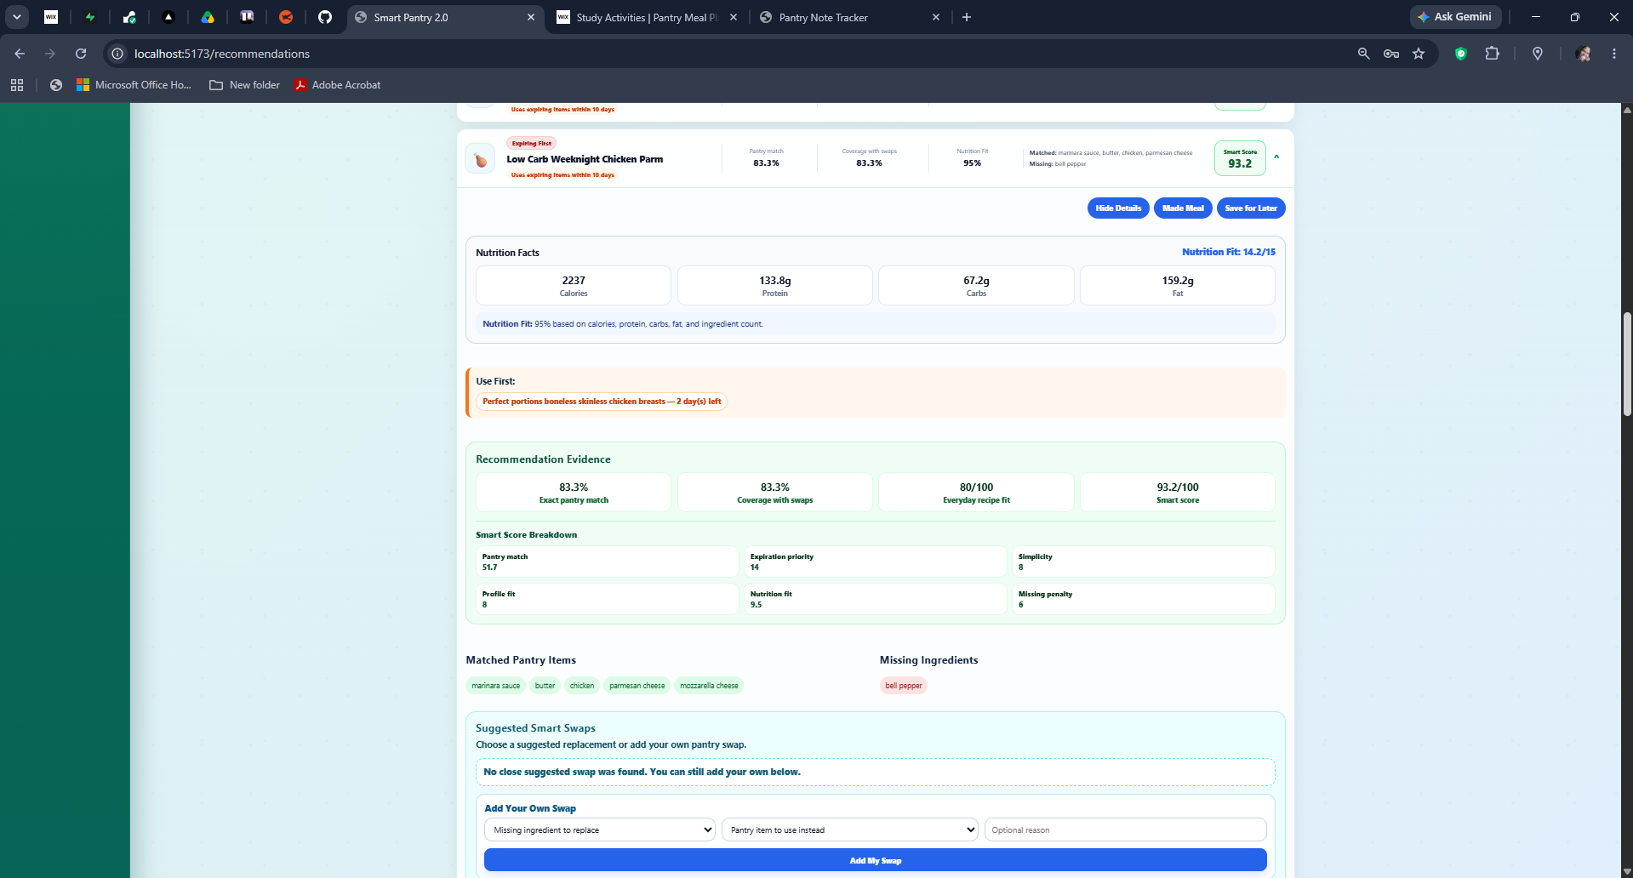
Figure 4.7. Smart Pantry recommendation card and evidence.

4.5.7 Recommendation History
Recommendation History stores participant decisions such as Made Meal, Used Elsewhere, Saved for Later, and Did Not Use. It provides both participant review and measurable study evidence.
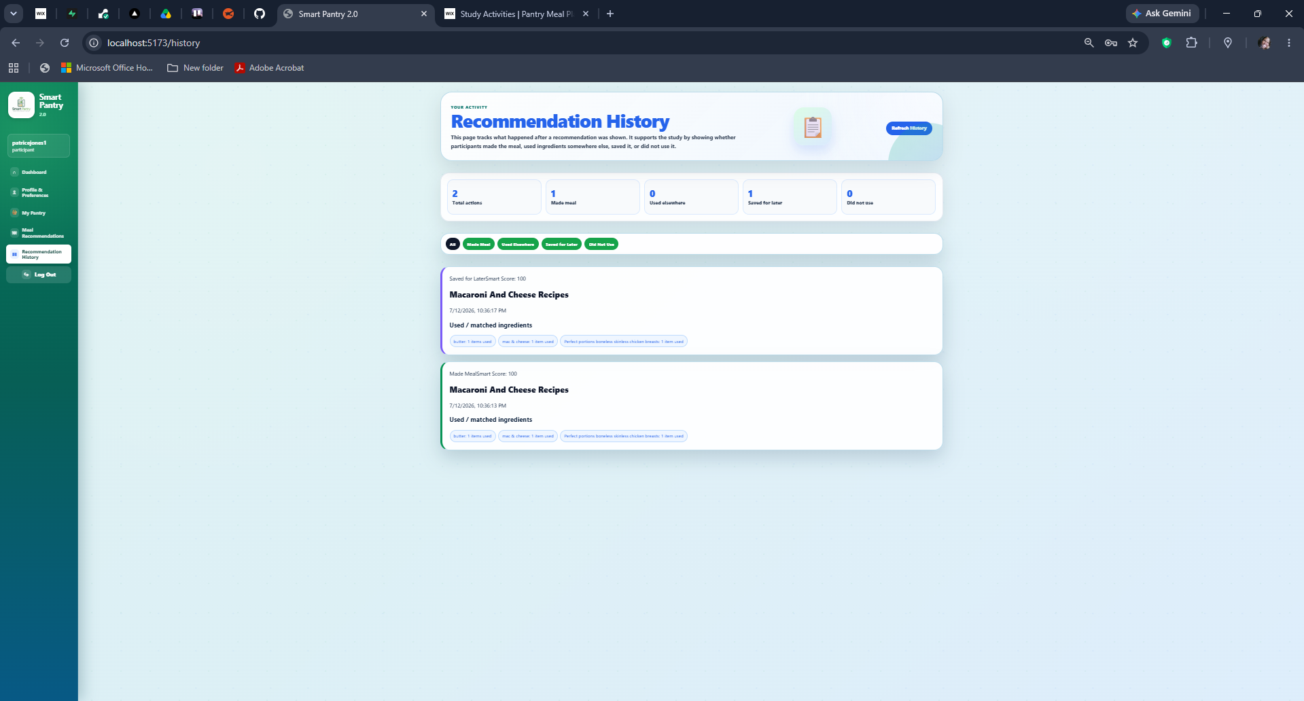
Figure 4.8. Smart Pantry Recommendation History.

4.5.8 Administrator Dashboard
The administrator dashboard summarizes participant totals, pantry records, Activity 1 manual tracking, recommendation actions, acceptance rate, and study metrics. Additional sections support completion review, recommendation evidence, and CSV exports.
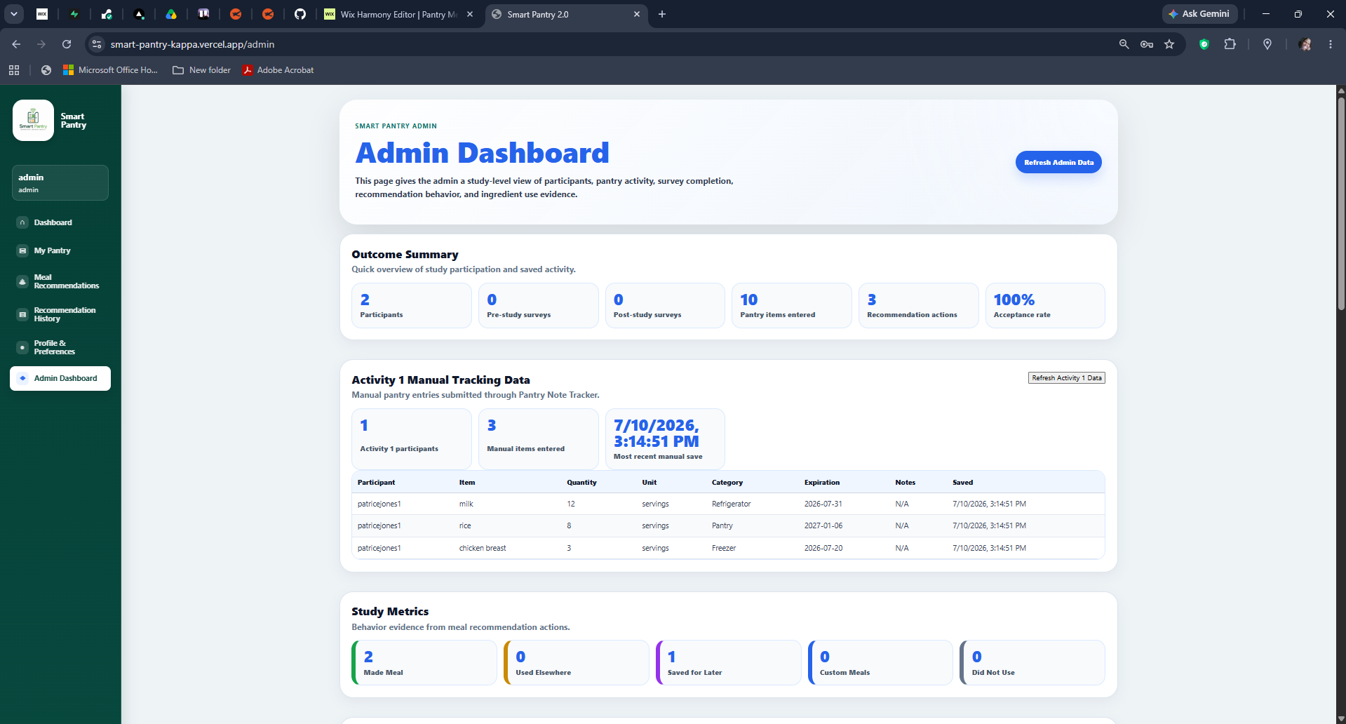
Figure 4.9. Administrator outcome and Activity 1 summary.
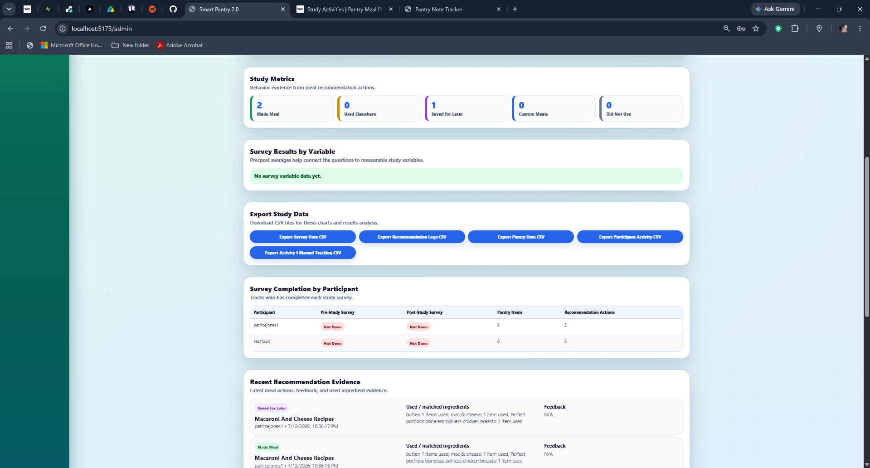
Figure 4.10. Administrator evidence and export interface.

Chapter 5 – Evaluation and Study Readiness

5.1 Evaluation Overview
The evaluation combines participant perception with application-generated evidence. Surveys measure the participant's starting point, experience with each activity, and final comparison. Smart Pantry records pantry entries, recommendation actions, swaps, ingredient use, and history. This combination reduces reliance on a single data source.

5.2 Evaluation Metrics
Table 5.1. Primary Evaluation Metrics
Evaluation area | Primary source
Pantry organization and awareness | Pre-study and post-study surveys
Meal-planning confidence | Pre-study and post-study surveys
Ease of use | Activity feedback forms
Recommendation quality | Smart Pantry feedback and open-ended responses
Recommendation acceptance | Recommendation History
Ingredient utilization | Application logs and participant reports
Smart Swap use | Recommendation logs
Overall preference | Post-study survey

5.3 Pilot Study
A pilot study was completed before full recruitment. The pilot checked the study website, form links, login process, pantry entry, recommendations, history, Smart Swaps, mobile usability, and administrative evidence. The pilot was used to improve the workflow rather than to make claims about the final research outcomes.
Changes resulting from the pilot included clearer study instructions, a neutral Wix study portal, survey wording changes, login and support updates, visible recommendation loading, more accurate recommendation categories, simplified participant-facing language, suggested and custom Smart Swaps, a separate Pantry Notes Tracker, and improved admin visibility.

5.4 Limitations and Threats to Validity
The target of at least 30 participants supports an initial within-subject evaluation but does not represent every household. Responses are partly self-reported and depend on participants completing the activities carefully. The fixed activity order may introduce learning or fatigue effects, and Samsung Food may change its interface or features during or after the study.
Some Smart Pantry features depend on external food, UPC, OCR, and hosting services. Differences in phones, browsers, internet speed, and participant cooking experience may also affect the experience. Finally, the structured study period does not measure long-term household use over several months.

5.5 Expected Contributions
The expected software contribution is a deployable full-stack pantry and recommendation platform. The expected recommendation contribution is an explainable ranking process that combines pantry availability, expiration, preferences, Nutrition Fit, and substitutions. The expected research contribution is a repeatable comparison workflow that combines participant feedback with application evidence.

Chapter 6 – Discussion, Future Work, and Conclusion

6.1 Discussion
Smart Pantry was developed around a specific distinction: recipe discovery and pantry decision support are related but not identical. A user may have access to thousands of recipes and still struggle to decide what should be cooked from current household inventory. The project therefore focuses on the connection between what is available, what should be used first, and what meal is realistic.
The three activities provide different perspectives. The Pantry Notes Tracker shows the effort and control of a manual method. Samsung Food shows the polish and recipe ecosystem of an established consumer application. Smart Pantry tests whether a more focused pantry-first workflow provides useful explanation, expiration evidence, and measurable interaction data.

6.2 Future Work
- Expand receipt OCR and item parsing accuracy.
- Support retailer or purchase-history imports while maintaining participant privacy.
- Improve mobile layout and consider a dedicated mobile application.
- Expand validated substitution relationships and collect participant-confirmed swaps.
- Use larger datasets and additional recommendation models while retaining explainability.
- Explore predictive expiration and personalized grocery suggestions.
- Conduct a longer-term study with a larger and more diverse sample.
- Evaluate counterbalanced activity order in a future experimental design.

6.3 Conclusion
This thesis presents Smart Pantry as both a pantry management application and a participant research platform. The project connects a neutral study website, surveys, three comparison activities, a full-stack web application, an explainable recommendation engine, Recommendation History, and administrative exports.
The broader contribution extends beyond a single application. The project demonstrates how software engineering, user-centered design, machine learning support, and structured evaluation can be combined to address an everyday household problem. Smart Pantry provides a foundation for future work involving intelligent food management, recommendation technologies, and sustainable household decision-making.

References
[1] U.S. Department of Agriculture, “Food Loss and Waste,” USDA. [Online]. Available: https://www.usda.gov/about-food/food-safety/food-loss-and-waste. [Accessed: May 1, 2026].
[2] U.S. Environmental Protection Agency, “United States 2030 Food Loss and Waste Reduction Goal,” EPA. [Online]. Available: https://www.epa.gov/sustainable-management-food/united-states-2030-food-loss-and-waste-reduction-goal. [Accessed: July 1, 2026].
[3] Samsung Food, “Samsung Food,” [Online]. Available: https://samsungfood.com/. [Accessed: May 1, 2026].
[4] Samsung Food Support, “How to Search for Recipes Using Your Available Ingredients,” [Online]. Available: https://support.samsungfood.com/hc/en-us/articles/30251599415956-How-to-Search-for-Recipes-Using-Your-Available-Ingredients. [Accessed: July 1, 2026].
[5] SuperCook, “Recipe Search by Ingredients,” [Online]. Available: https://www.supercook.com/. [Accessed: May 1, 2026].
[6] K. J. P. Ortiz, P. N. P. Bautista, M. V. D. Dimailig, and A. C. D. Llamzon, “Recipe Recommendation System Using IoT-Based Food Inventory Management of Perishables for Household Food Waste Reduction,” Chemical Engineering Transactions, vol. 106, pp. 361–366, 2023, doi: 10.3303/CET23106061. [Accessed: Jun. 1, 2026].
[7] M. S. Rodrigues, J. F. Ribeiro, D. F. Pereira, and P. J. Cardoso, “RecipeIS—Recipe Recommendation System Based on Recognition of Food Ingredients,” Applied Sciences, vol. 13, no. 13, Art. no. 7880, 2023, doi: 10.3390/app13137880. [Accessed: Jun. 1, 2026].
[8] S. Chhipa, S. B. Dabre, and R. A. Chaudhari, “Recipe Recommendation System Using TF-IDF,” ITM Web of Conferences, vol. 44, Art. no. 02006, 2022, doi: 10.1051/itmconf/20224402006. [Accessed: Jun. 1, 2026].
[9] M. A. Chatti, M. Guesmi, and A. Muslim, “Visualization for Recommendation Explainability: A Survey and New Perspectives,” arXiv:2305.11755, 2023. [Accessed: Jun. 1, 2026].
[10] Y. Zhang and X. Chen, “Explainable Recommendation: A Survey and New Perspectives,” Foundations and Trends in Information Retrieval, vol. 14, no. 1, pp. 1–101, 2020, doi: 10.1561/1500000066. [Accessed: Jun. 1, 2026].
[11] scikit-learn Developers, “RandomForestRegressor,” scikit-learn Documentation. [Online]. Available: https://scikit-learn.org/stable/modules/generated/sklearn.ensemble.RandomForestRegressor.html. [Accessed: May 1, 2026].
[12] Open Food Facts, “Open Food Facts—World Food Database,” [Online]. Available: https://world.openfoodfacts.org/. [Accessed: Jun. 20, 2026].

Appendix A – Study Protocol
The official Study Protocol is presented through the Pantry & Meal Planning Study website. It instructs participants to review consent, complete the baseline survey, complete Activities 1 through 3 with their matching feedback forms, complete the post-study survey, and submit the study-completion step. The final participant-facing wording should be reproduced here from the approved Wix page before final submission.

Appendix B – Informed Consent
Insert the approved informed-consent instrument used for participant recruitment and study participation. The final version should include the purpose, procedures, expected time, voluntary-participation statement, privacy statement, risks, benefits, withdrawal process, and contact information.

Appendix C – Pre-Study Survey
Insert the complete approved pre-study survey, including question wording, response type, and scale labels. This appendix should preserve the same order used in the Google Form.

Appendix D – Activity 1 Feedback Instrument
Insert the complete Pantry Notes Tracker feedback form.

Appendix E – Activity 2 Feedback Instrument
Insert the complete Ingredient Recipe Finder / Samsung Food feedback form.

Appendix F – Activity 3 Feedback Instrument
Insert the complete Pantry Recommendation Tool feedback form.

Appendix G – Post-Study Survey
Insert the complete approved post-study survey, including comparison and open-ended questions.

